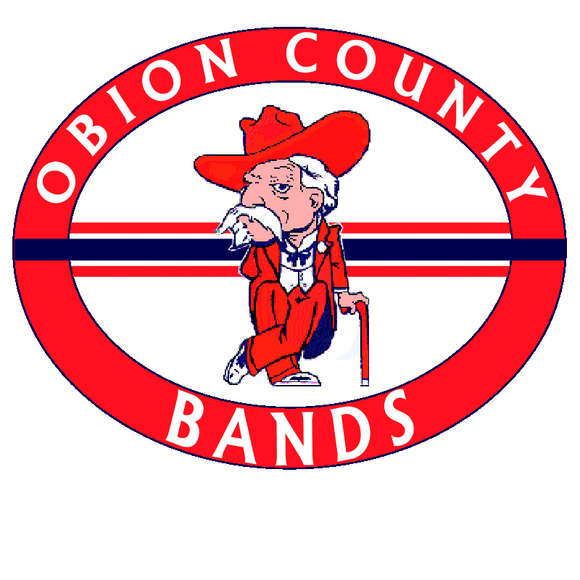
Obion County Central High School Band Phone: 731-536-4688
528 Hwy 51 Ext: 3550
Troy, TN www.occhsband.org
38260

Dear Students and Parents,

It is that time again! Band camp is right around the corner. Band Camp will be at Central. The dates for band camp are:

July 16 & 17: 8 am-12 pm
Freshmen, percussion, guard report to OC band room for marching/visual fundamentals
1 pm-5 pm
All members report to OC band room for music rehearsal

July 20-24 & 27-28: 8 am-8pm
All members report to OC band room to learn 2020 show
Lunch break 11:30 am-1 pm
Dinner break 4:30 pm-6 pm

July 29: Off

July 30: 5 pm-8pm
All members report to OC band room for rehearsal for preview show

July 31: All members report time TBA
Chicken supper and preview show

Letters have been sent out to all students with complete addresses. If you know of someone who did not receive a letter, please make them aware of this information.
The fee for Band Camp is $125 if paid in full by the end of the first day of camp and will go up to $150 if paid after this date, unless prior arrangements have been made (if money is an issue, please talk with Mr. Byrd). We have NEVER and will NEVER turn someone away due to financial hardships.
Meal times are from 11:30 – 1:00, and 4:30 - 6:00 on 8-8 days. Students will have some options for Meals. Option 1 is to eat on campus with us by bringing their meals or eating from our concession stand. Concession stand meals include cold cut sandwiches, chips, and drinks. Price is approximately $2. Option 2 is students may be picked up by their parents or ride with other students with parental permission to go to meals (slip is included). Option 3 is students who drive will be allowed to leave campus with parental permission (slip is included). Due to safety concerns, the students will not be allowed to walk or ride bikes to local convenience stores. Also, students are not allowed to bring skateboards or roller skates/blades on campus.
As we enter July in Tennessee, the temperatures begin to soar. Please keep this in mind when preparing for each day. Your clothing needs to be light colored in the hot weather. Sleeveless shirts are fine, but NO tank, tube, mid-riff, or bikini tops. Staying cool is important, but please remember to be covered. Each member needs to bring a container of powder Gatorade. This will be made up by the student leaders for all the students. Also, it is a good idea to wear a hat, sunglasses, bring a towel to get wet, sunscreen, and a jug of water. Tennis shoes are required. No other kinds of shoes are allowed. Please make sure you eat something for breakfast even if you are not a breakfast eater. Avoid milk and other items that do not settle on your stomach very easily. We want all our students to be safe through this hot weather.
We look forward to seeing all of you in a couple of weeks. Please remember your medical release forms. They need to be notarized. Mr. Byrd needs these for medical reasons. The photo permission form has been included. It needs to be returned to Mr. Byrd if you do not want your student’s picture used on the band website. Also, any parent who can help during these weeks (even if it is just for part of a day or two) is greatly appreciated. All you need to do is show up. Thanks in advance.

Sincerely,

Mr. Jonathan L. Byrd
Band Director
Obion County Central High School
731-536-4688 Ext. 3550

